**Mini Project Report**

**Submitted By:**

**Ranjith M (BGSW/PJ-ETA-FTP-C)**

**MFJ1COB**

**TABLE OF CONTENTS**

|  |  |  |
| --- | --- | --- |
| S.no | Contents | Page.no |
| 1 | Requirements | 3 |
| 2 | Problem Statement | 6 |
| 3 | Project Development CyCLe | 5 |
| 4 | Architecture | 7 |
| 5 | Connection | 11 |
| 6 | flow chart diagram | 12 |
| 7 | algorithm | 14 |
| 8 | Program | 16 |
| 9 | REQUIREMENTS TABLE | 26 |
| 10 | test cases | 29 |
| 11 | OUTPUT | 33 |

HARDWARE REQUIREMENT

# THE STM32F405RGT6 DEVELOPMENT BOARD IS A ROBUST PLATFORM BASED ON THE STM32F405RGT6 MICROCONTROLLER, FEATURING A POWERFUL ARM CORTEX-M4 CORE OPERATING AT UP TO 168 MHZ, ABUNDANT MEMORY, DIVERSE PERIPHERALS, AND CONNECTIVITY OPTIONS. IT STREAMLINES EMBEDDED SYSTEM DEVELOPMENT BY OFFERING INTEGRATED DEBUGGING TOOLS AND USER-FRIENDLY COMPONENTS FOR RAPID PROTOTYPING.

# • ST-LINK V2 IS A VERSATILE DEBUGGER AND PROGRAMMER DESIGNED FOR STM32 MICROCONTROLLERS. IT ENABLES REAL-TIME DEBUGGING, FLASH MEMORY PROGRAMMING, AND VIRTUAL COM PORT COMMUNICATION. WITH SUPPORT FOR SWD AND JTAG INTERFACES, ST-LINK V2 ENHANCES DEVELOPMENT EFFICIENCY BY FACILITATING CODE VERIFICATION, TROUBLESHOOTING, AND FIRMWARE LOADING.

# • JUMPER WIRES

# • POWER CABLE (FOR MORE THAN 3.3 V APPLICATIONS)

SOFTWARE REQUIREMENT:

STM32CUBEIDE 1.11.0 IS STMICROELECTRONICS' INTEGRATED DEVELOPMENT ENVIRONMENT DESIGNED FOR STM32 MICROCONTROLLERS. FEATURING AN INTUITIVE INTERFACE, IT UNIFIES CODE EDITING, DEBUGGING, AND PROJECT MANAGEMENT. WITH ENHANCED CODE GENERATION THROUGH STM32CUBEMX INTEGRATION, ADVANCED DEBUGGING TOOLS, AND SUPPORT FOR A WIDE RANGE OF STM32 DEVICES, THIS VERSION SIMPLIFIES EMBEDDED DEVELOPMENT. UPDATES IN VERSION 1.11.0 OFFER IMPROVED PERFORMANCE, MAKING IT AN ESSENTIAL TOOL FOR CREATING EFFICIENT AND RELIABLE EMBEDDED APPLICATIONS.

**Design Requirement 1:**

1- If Ignition OFF--> No operation

2- Ignition switch 1st press -> Ignition Status ON-> Next Press-> Ignition Status OFF (Toggle Mechanism)

3- If Ignition ON--> Ignition Status ON

i) If Right Indicator ON (Switch1 1st press-> Right Indicator Status ON -> next press-> Right Indicator Status Off)

- LED3 will blink continuously with a frequency of 0.5Hz 50% Duty).

- Buzzer will indicate with a tone with a frequency of 0.5Hz 50% Duty Buzzer should be in synch with the corresponding Indicator LED)

*Above status won't work if both Left & Right Indicator Switches are ON

ii) If Left Indicator ON (Switch3 1st press-> Left Indicator Status ON -> next press-> Left Indicator Status Off)

- LED4 will blink continuously with a frequency of 0.5Hz 50% Duty.).

- Buzzer will indicate with a tone with a frequency of 0.5Hz 50% DutyBuzzer should be in synch with the corresponding Indicator LED)

*Above status won't work if both Left & Right Indicator Switches are ON

iii) Simulated Fuel Indicator status to be continuously shown in Live Expression Window. Simulate the POT1 as Fuel Level Indicator & design respective ADC driver to display the Fuel Level in the STLink Debugger Live Window. Ex: Maximum position of pot is 100% and the minimum position of the pot is 0% and the display of fuel level should show with resolution of 1%

iv) If Head Light switch is pressed (Switch4 1st press->Light Low Beam ->next press-> Light High Beam-> next press-> Parking Light (both LED4 & LED3) blink at 1Hz-> next press OFF

- For Low Beam: LED1 with 10% PWM Duty Cycle

- For High Beam: LED1 with 90% PWM Duty Cycle

- For Parking Light: Both LED3 & LED4 blink & Buzzer to indicate with different tone (with a frequency of 2Hz 50% Duty) then indicator

*Parking light won't operate, if either Left or Right Indicator is ON

v) UART is continuously passing a status message 'j' from Rx to Tx & the status has to be shown on STLink Debugger Live Window. Loop Back UART3 RX & TX pins to verify the data sent & received. (Find the Rx & Tx pins of UART3 with the help of datasheet). Every 500msec the UART status must be displayed on STLink Debugger Live Window.

**Design Requirement II:**

1- If Ignition OFF--> No operation: LCD to display "CAROFF"

2- Ignition switch 1st press -> Ignition Status ON-> Next Press-> Ignition Status OFF (Toggle Mechanism)

3- If Ignition ON--> Ignition Status ON: LCD to display "CARON"

i) If Right Indicator ON (Switch1 1st press-> Right Indicator Status ON -> next press-> Right Indicator Status Off)

- LCD to display "Right"

- Buzzer will indicate with a beep frequency of 0.5Hz 50% Duty

*Above status won't work if both Left & Right Indicator Switches are ON

ii) If Left Indicator ON (Switch3 1st press-> Left Indicator Status ON -> next press-> Left Indicator Status Off)

- LCD to display "Left"

- Buzzer will indicate with a with a frequency of 0.5Hz 50% Duty (Same as Right Indicator tone)

*Above status won't work if both Left & Right Indicator Switches are ON

iii) Simulated Fuel Indicator status to be continuously displayed on LCD as: "Fuel:value". Simulate the POT1 as Fuel Level Indicator & design respective ADC driver to display the Fuel Level.

iv) If Head Light switch is pressed (Switch4 1st press->Light Low Beam ->next press-> Light High Beam-> next press-> Parking Light(both LED4 & LED3) blink-> next press OFF

- For Low Beam: LED1 with 10% PWM Duty Cycle: LCD to display "LoBeam"

- For High Beam: LED1 with 90% PWM Duty Cycle: LCD to display "HiBeam"

- For Parking Light: LCD to display "park" & Buzzer to indicate with different tone(with a frequency of 2Hz 50% Duty) than indicator

*Parking mode won't operate, if either Left or Right Indicator is ON

v) UART is continuously passing a status message 'j' from Rx to Tx & the status has to be shown on LCD at regular interval.

Loop Back UART3 RX & TX pins to verify the data sent & received(Find the Rx & Tx pins of UART3 with the help of datasheet). Every 500msec the UART status has to be displayed on LCD as below:

-If Message passed: LCD to display"U:OK"

-If message not passed: LCD to display"U:NO"

Problem Statement**:**

1. If Ignition is OFF -> No operation
2. Ignition Switch 1st press -> Ignition Status ON -> Next Press -> Ignition Status OFF
   1. If Ignition ON -> Ignition Status ON
   2. If Right Indicator ON (Switch1 1st press -> Right Indicator Status ON -> Next press -> Right Indicator Status OFF)
      1. LED3 will blink continuously
      2. Buzzer will indicate with a tone
      3. Above status won’t work if both Left and Right indicator switches are ON
   3. If Left indicator ON (Switch3 1st press -> Left Indicator Status ON -> Next press -> Left Indicator Status OFF)
      1. LED4 will blink continuously
      2. Buzzer will indicate with a tone
      3. Above status won’t work if both Left and Right indicator switches are ON
   4. Simulated Fuel Indicator status to be continuously shown in Live expression window.
   5. If Headlight switch is pressed (Switch 4 1st press -> Light Low Beam -> Next press -> Light High Beam -> Next press -> Parking Light (Both LED4 and LED3) blink -> Next press OFF
      1. For Low Beam: LED1 with 10% PWM Duty Cycle
      2. For High Beam: LED2 with 90% PWM Duty Cycle
      3. For Parking Light: Both LED3 and LED4 blink and buzzer to indicate with different tone than indicator.
      4. Parking light won’t operate, if either left or right indicator is ON
   6. UART is continuously passing a status message ‘j’ from Rx to Tx and the status must be shown in live expression window.

Project Development Cycle:

Model**:**

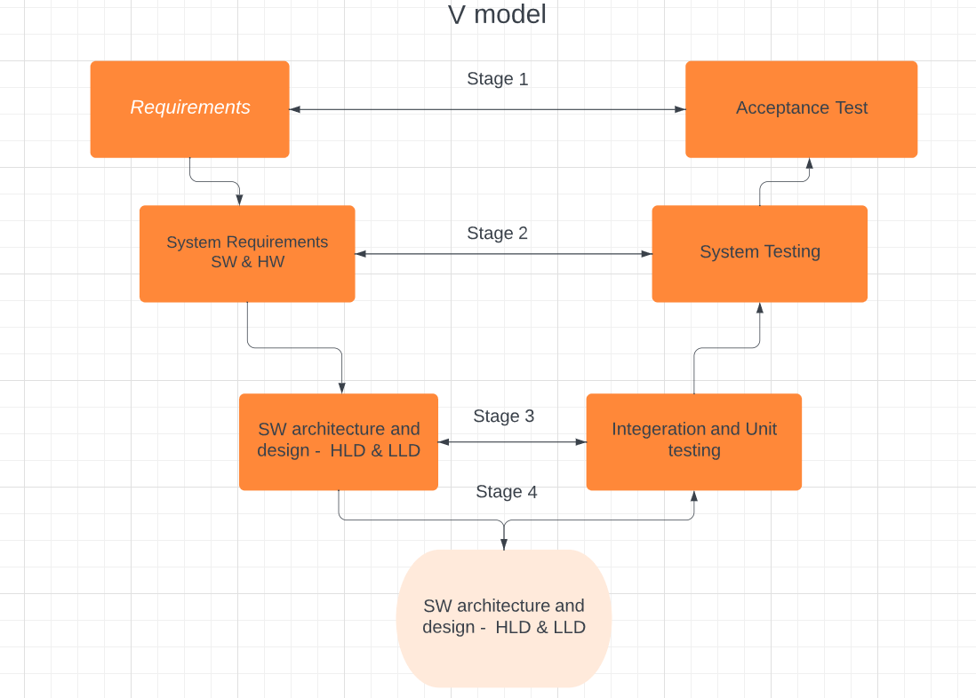

**ARCHITECTURE:**

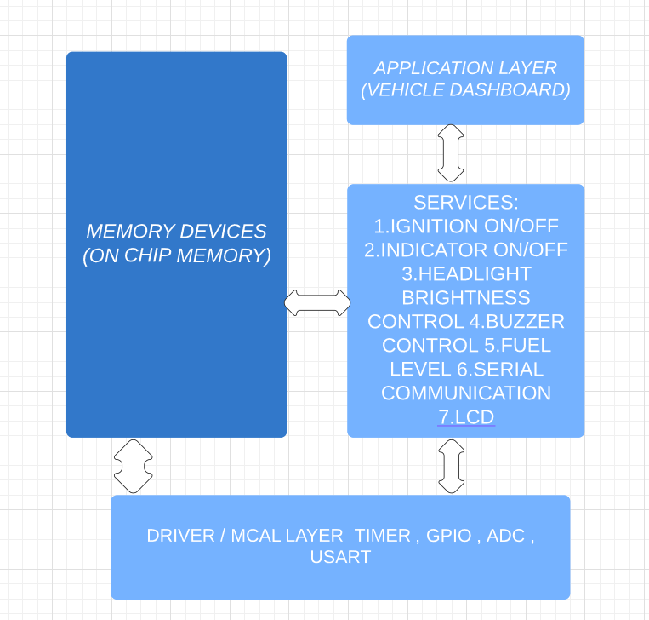

# Requirements:

# Architecture:

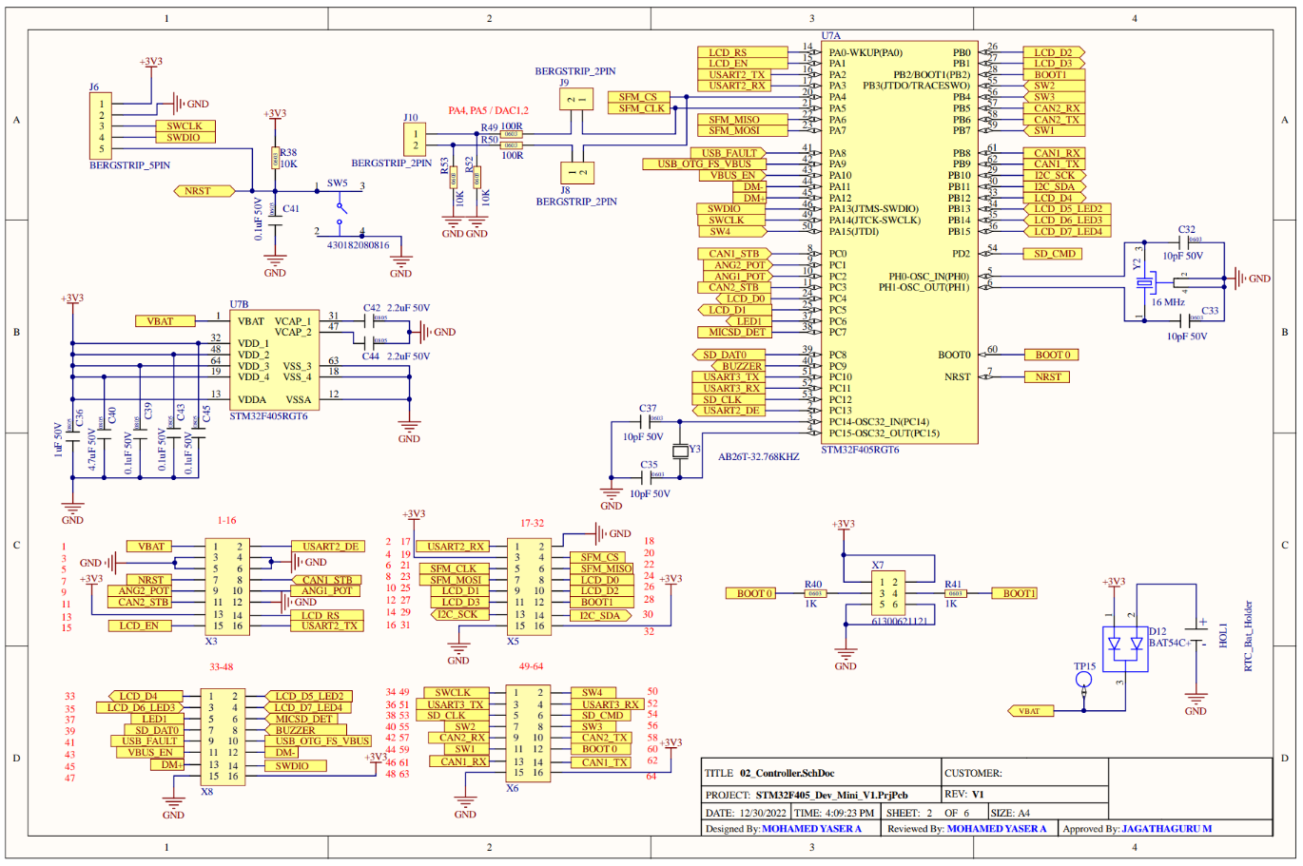

## Board Layout:

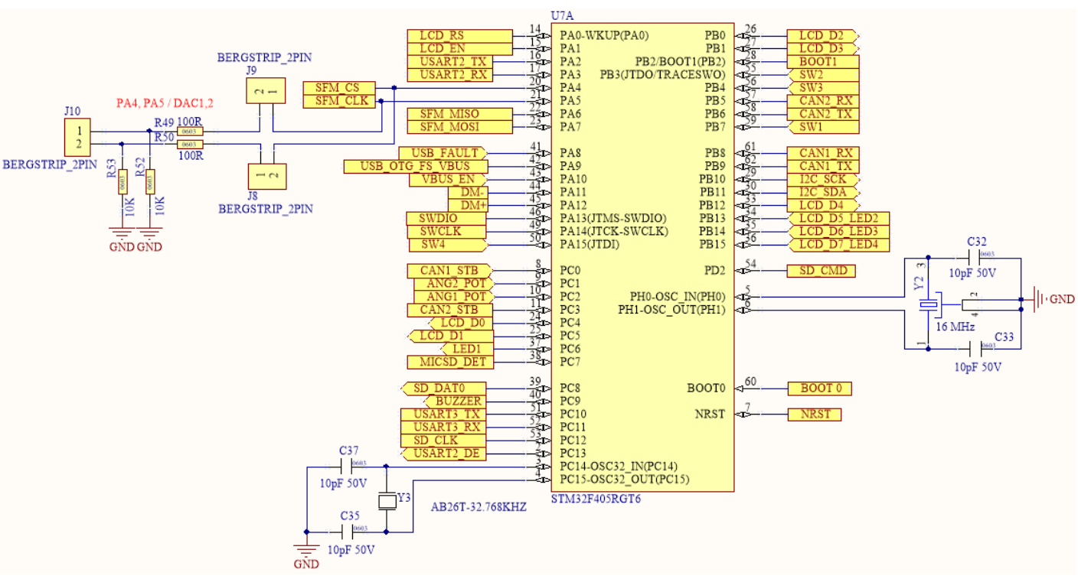

Connection**:**

## General Purpose Input Output: (GPIOs)

|  |  |  |  |  |
| --- | --- | --- | --- | --- |
| S No | Item Type | IO | Type | Description |
| 1 | LED1 | PB15 | OUT | Orange Color — LD3 |
| 2 | LED2 | PB14 | OUT | Green Color — LD4 |
| 3 | LED3 | PB13 | OUT | Red Color - LD5 |
| 4 | LED4 | PC6-TIM3_CH1 | OUT/PWM | Blue Color - LD6 |
| 5 | Switch 1 | PA15 | INPUT | Switch input |
| 6 | Switch2 | PB7 | INPUT | Switch input |
| 7 | Switch3 | PB4 | INPUT | Switch input |
| 8 | Switch4 | PB3 | INPUT | Switch input |
| 9 | Buzzer | PC9 | Output | Indicator and Parking sound |
| 13 | POT 1 | PC12(ADC1) | Analog | INPUT (Simulating Fuel Level) |
| 11 | UART3 RX | PC10 | Alternate Function AF (8) | UART Receiving Pin |
| 12 | UART3 TX | PC11 | Alternate Function AF (8) | UART Receiving Pin |
| 14 | LCD | PA0 | Digital Output | LCD_RS |
| PA1 | Digital Output | LCD_EN |
| PB12 | Digital Output | LCD_D4 (When LED OFF) |
| PB13 | Digital Output | LCD_D5 (When LED OFF) |
| PB14 | Digital Output | LCD_D6 (When LED OFF) |
| PB15 | Digital Output | LCD_D7 (When LED OFF) |

Flowchart:

WITHOUT LCD:

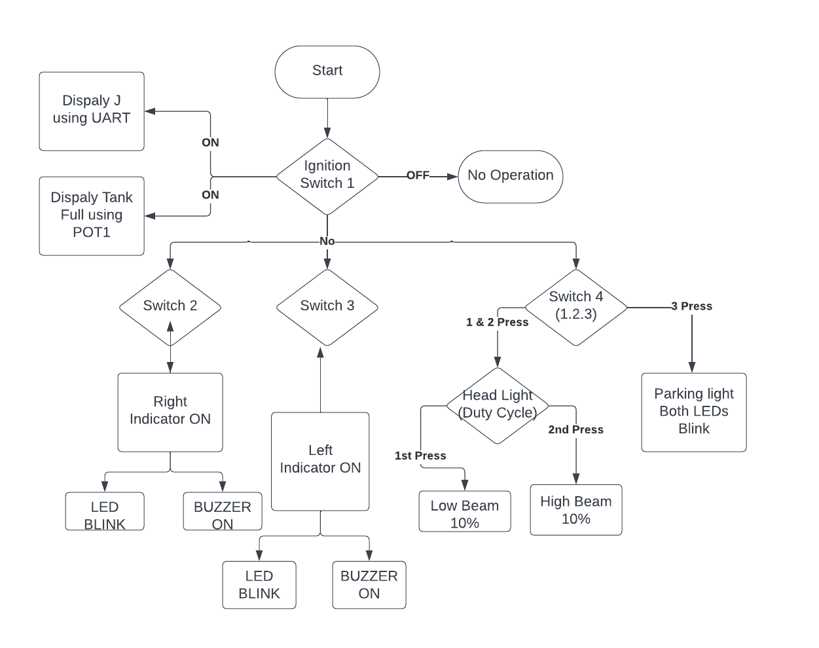

WITH LCD:

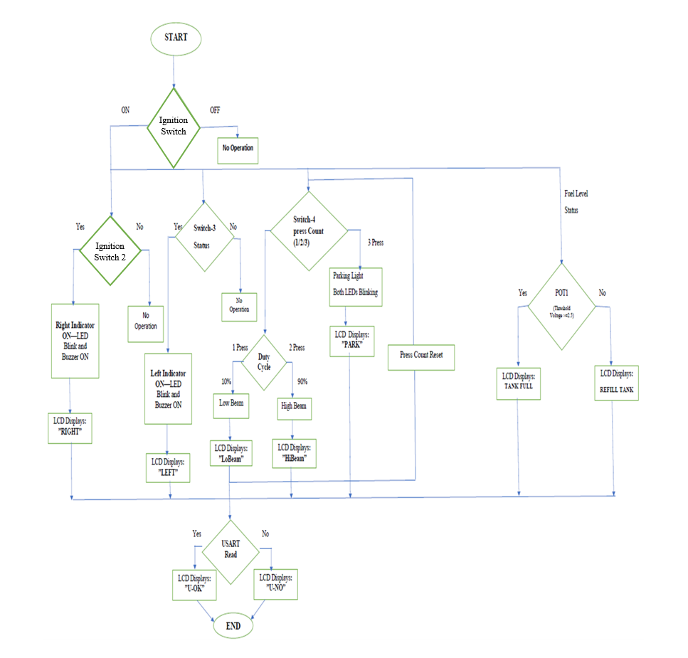

Algorithm:

STEP 1: Header Files and Definitions:

The code includes necessary header files, such as stdint.h and stdio.h, and defines various constants and macros related to pins and modes.

STEP 2: Header Comment:

The code begins with a header comment that includes the file name, author, brief description, and copyright information.

STEP 3: Global Variables:

There are global variables defined to hold values related to ADC results, a character for UART communication, and others.

STEP 4: Function Prototypes:

The program contains prototypes for various functions used in the code.

STEP 5: Main Function:

The main () function appears to be the main control loop of the program.

It configures GPIO pins, initializes variables, and enters an infinite loop.

Inside the loop, it continuously reads input from various pins and performs actions based on the input.

STEP 6: Functions:

* tim3_pc6_set_dutycycle(): This function sets the duty cycle for a PWM signal on TIM3 Channel 1 or 4 based on the provided frequency and duty cycle percentage.
* pc6_tim3_pwm_config(): This function configures GPIOC Pin 6 for PWM and initializes TIM3 for PWM generation.
* pwm_moder(): This function sets GPIOC Pin 6 for PWM mode.
* timer_delay(): This function uses TIM2 to create a delay of a specified number of seconds.
* ADC_init(): This function initializes ADC1 and the corresponding GPIO pin for analog input.
* start_conversion(): This function initiates ADC conversion.
* ADC_result(): This function waits for the ADC conversion to complete and returns the result.

STEP 7: Main Loop:

7.1 Read ADC value and store it in Value.

7.2 Read statuses of buttons and switches into pinstatus1, pinstatus2, pinstatus3, and pinstatus4.

7.3 If pinstatus1 is 0, wait for it to become 1 (ignition button released).

7.4 Increment ign counter by 1 to indicate ignition detected.

7.5 If ign equals 1:

* Check pinstatus2 and pinstatus3 for left and right turn indicator buttons.
* If pressed, increment left or right counter accordingly.
* Toggle corresponding LED and buzzer if required.
* Check pinstatus4 for headlight control button.
* If pressed, increment head counter for headlight mode control.

7.6 Handle headlight modes based on head value:

* If head equals 1 or 2:
* Set PWM mode for brightness control.
* Set duty cycle and frequency based on mode.
* If head equals 3:
* Toggle LEDs, buzzer, and wait for a while.
* If head equals 4, turn off all headlight and indicator functions.

7.7 If ign equals 2, it indicates ignition turned off and on again:

* Turn off buzzer and certain LEDs.
* Reset counters for ignition, indicators, and headlight modes.

STEP 8: Termination of Functions:

When certain conditions are met, the program resets or turns off different functionalities, such as turning off LEDs and stopping buzzer sound.

STEP 9: Termination of Ignition:

When the ignition is detected twice, the program turns off LEDs, resets the ignition counter, and resets other counters and modes.

STEP 10: End the program

CODE:

LCD.c

**#include**"stm32f405xx.h"

**#include**<stdint.h>

**#include**"lcd.h"

**void** **lcd_gpio_init**(**void** )

{

/*******GPIO Initialise********/

//Enable GPIO C Clock in AHB1ENR

RCC->AHB1ENR|=(0xF<<0);

//Set PC4 & PC5 to output Mode

GPIOC->MODER|=(5<<8);

//Set PB0 & PB1 to output Mode

GPIOB->MODER|=(5<<0);

//Set PB12,PB13,PB14 & PB15 to output Mode

GPIOB->MODER|=(5<<24);

GPIOB->MODER|=(5<<28);

//Set PA0-RS, PA1-EN[output mode]

GPIOA->MODER|=(5<<0);

}

**void** **LCD**(uint8_t val, uint8_t cmd)

{

uint8_t data;

//time_delay(10);

//PC4

data=val&0x01;

**if**(data)

GPIOC->ODR|=(1<<4);

**else**

GPIOC->ODR&=~(1<<4);

//PC5

data=((val>>1)&0x01);

**if**(data)

GPIOC->ODR|=(1<<5);

**else**

GPIOC->ODR&=~(1<<5);

//PB0

data=(val>>2)&0x01;

**if**(data)

GPIOB->ODR|=(1<<0);

**else**

GPIOB->ODR&=~(1<<0);

//PB1

data=(val>>3)&0x01;

**if**(data)

GPIOB->ODR|=(1<<1);

**else**

GPIOB->ODR&=~(1<<1);

//PB12

data=(val>>4)&0x01;

**if**(data)

GPIOB->ODR|=(1<<12);

**else**

GPIOB->ODR&=~(1<<12);

//PB13

data=(val>>5)&0x01;

**if**(data)

GPIOB->ODR|=(1<<13);

**else**

GPIOB->ODR&=~(1<<13);

//PB14

data=(val>>6)&0x01;

**if**(data)

GPIOB->ODR|=(1<<14);

**else**

GPIOB->ODR&=~(1<<14);

//PB15

data=(val>>7)&0x01;

**if**(data)

GPIOB->ODR|=(1<<15);

**else**

GPIOB->ODR&=~(1<<15);

**if** (cmd) //command(PA0)

{

GPIOA->ODR|=(1<<0); //RS=1(data)

}

**else**

{

GPIOA->ODR&=~(1<<0); //RS=0(command)

}

//PA1-EN

GPIOA->ODR|=(1<<1);

**for** (**unsigned** **int** i=0;i<16800;i++);

GPIOA->ODR&=~(1<<1);

**for** (**unsigned** **int** i=0;i<16800;i++);

}

**void** **LCD_init**(**void** )

{

LCD(0x01,0);

LCD(0x38,0);

LCD(0x06,0);

LCD(0x0C,0);

}

**void** **Lprint**(**char** *str)

{

uint8_t i=0;

**while**(str[i]!='\0')

{

LCD(str[i],1);

i++;

}

}

**void** **start**(**void**)

{

**for**(**int** h=0;h<2;h++)

{

**for**(**int** r=0;r<9;r++){

**for**(**int** m=0;m<6;m++)

{

**for**(**int** i=0;i<9;i++)

{

**for**(**int** s=0;s<6;s++)

{

**for**(**int** e=0;e<9;e++)

{

LCD(0x80,0);

LCD(h+48,1);

LCD(r+48,1);

LCD(':',1);

LCD(m+48,1);

LCD(i+48,1);

LCD(':',1);

LCD(s+48,1);

LCD(e+48,1);

**for**(**int** q=0;q<100000;q++);

}

}

}

}

}

}

}

**void** **pause**(**void**)

{

LCD(0x80,0);

LCD(0+48,1);

LCD(0+48,1); LCD(':',1);

LCD(0+48,1);

LCD(0+48,1); LCD(':',1);

LCD(0+48,1);

LCD(0+48,1);

}

UART.c

/*

* uart.c

* Author: MFJ1COB

*/

// UART2 TX RX PA2-->TX (Pin 16 on X3) PA3-->RX (Pin 17 on X5)

**#include** <stdint.h>

**#include** "stm32f4xx.h"

**#include** "uart.h"

**#define** SYS_FREQ 16000000

**#define** APB1_CLK SYS_FREQ

**#define** UART_BAUDRATE 115200

**void** **UART2_init**(**void**)

{

/* * GPIO configration for Port A */

RCC->AHB1ENR|=(1U<<0);

GPIOA->MODER |=(1U<<7);

GPIOA->MODER &=~(1U<<6); // PA3 AF mode USART2_RX

GPIOA->MODER |=(1U<<5);

GPIOA->MODER &=~(1U<<4); // PA2 AF mode USART2_TX

/*

* Set PA2 and PA3 AF type to UART_TX & UART_RX (AF07) */

GPIOA->AFR[0] |=(1U<<8);

GPIOA->AFR[0] |=(1U<<9);

GPIOA->AFR[0] |=(1U<<10);

GPIOA->AFR[0] &= ~(1U<<11);

GPIOA->AFR[0] |=(1U<<12);

GPIOA->AFR[0] |=(1U<<13);

GPIOA->AFR[0] |=(1U<<14);

GPIOA->AFR[0] &=~(1U<<15);

/*

* UART Configration

*/

RCC->APB1ENR |=(1U<<17); //Enable clock Access to UART2

// Configure the baudrate

UART_Set_Baudrate(USART2,APB1_CLK, UART_BAUDRATE);

// Configure the Transfer Direction

USART2->CR1 = ((1U<<3) | (1U<<2));

//Enable UART2

USART2->CR1 |= (1U<<13);

}

**void** **UART2_write**(**int** ch)

{

// Check the Transmit data rgister is empty

**while**(!(USART2->SR & (1U<<7)));

// Write th data to Transmit Data Reg

USART2->DR =(ch & 0xFF);

}

**static** **void** **UART_Set_Baudrate**( USART_TypeDef *USARTx ,uint32_t Periphclk,uint32_t BaudRate)

{

USARTx->BRR =compute_uart_bd(Periphclk,BaudRate);

}

**static** uint16_t **compute_uart_bd**(uint32_t PeriphClk, uint32_t BaudRate)

{

**return** ((PeriphClk + (BaudRate/2U))/BaudRate);

}

**char** **UART2_READ**(**void**)

{

/*

* check the RX data Register is empty */

**while**(!(USART2->SR & (1U<<5)));

//READ data

**return** USART2->DR;

}

MAIN.c

/**

******************************************************************************

* @file : main.c

* @author : Ranjith

* @brief : Mini project for car indicator, Head light and UART

******************************************************************************

* @attention

*

* Copyright (c) 2023 STMicroelectronics.

* All rights reserved.

*

* This software is licensed under terms that can be found in the LICENSE file

* in the root directory of this software component.

* If no LICENSE file comes with this software, it is provided AS-IS.

*

******************************************************************************

*/

**#include** <stdint.h>

**#include** <stdio.h>

**#include** "stm32f405xx.h"

//global variables

uint32_t Value;

**char** key;

// Function prototypes

**static** **void** **tim3_pc6_set_dutycycle**(uint32_t freq, uint32_t duty_cycle, uint8_t channel);

**static** **void** **pc6_tim3_pwm_config**(**void**);

**static** **void** **pwm_moder**(**void**);

**static** **void** **timer_delay**(**int** sec);

**static** **void** **ADC_init**(**void**);

**static** **void** **start_conversion**(**void**);

**static** uint32_t **ADC_result**(**void**);

**int** **main**()

{

pc6_tim3_pwm_config();

ADC_init();

start_conversion();

UART2_init();

// Enable clock for GPIOA, GPIOB, and GPIOC

RCC->AHB1ENR |= (1 << 0) | (1 << 1) | (1 << 2);

// Configure GPIOB pins

GPIOB->MODER |= (1 << 26); // Set PB13 as general-purpose output mode

GPIOB->MODER &= ~(1 << 27); // Clear PB13 alternate function mode

GPIOB->MODER |= (1 << 28); // Set PB14 as general-purpose output mode

GPIOB->MODER &= ~(1 << 29); // Clear PB14 alternate function mode

GPIOB->MODER |= (1 << 30); // Set PB15 as general-purpose output mode

GPIOB->MODER &= ~(1 << 31); // Clear PB15 alternate function mode

// Configure GPIOC pins

GPIOC->MODER |= (1 << 18); // Set PC9 as general-purpose output mode

GPIOC->MODER &= ~(1 << 19); // Clear PC9 alternate function mode

// Initialize indicator counters and headlight mode

**int** ign = 0, left = 0, right = 0, head = 0;

// Turn on initial LEDs

GPIOB->ODR |= (1 << 13); // Turn on the LED connected to PB13

GPIOB->ODR |= (1 << 14); // Turn on the LED connected to PB14

GPIOB->ODR |= (1 << 15); // Turn on the LED connected to PB15

**while**(1)

{

**while**(!(ADC1->SR) & (1U<<1));

Value=ADC_result()/41;

**int** pinstatus1= GPIOA->IDR & (1<<15);

**int** pinstatus2= GPIOB->IDR & (1<<4);

**int** pinstatus3= GPIOB->IDR & (1<<3);

**int** pinstatus4= GPIOB->IDR & (1<<7);

**if**(pinstatus1==0)

{

**while**(!(GPIOA->IDR & (1<<15)));

ign++;

}

**if**(ign==1)

{

GPIOB->ODR &= ~(1<<13);

UART2_write('j');

key=UART2_READ();

**if**(pinstatus2==0)

{

**while**(!(GPIOB->IDR & (1<<4)));

**if**(right!=1)

{

left++;

}

}

**if**(left==1 && head!=3)

{

GPIOB->ODR ^=(1<<14); //led toggle

GPIOC->ODR ^= (1<<9); //buzzer toggle

timer_delay(1); //for creating one second delay

}

**else** **if**(left==2)

{

GPIOC->ODR &=~(1<<9); //turning buzzer off

GPIOB->ODR |=(1<<14); //turning led off

left=0;

}

**if**(pinstatus3==0)

{

**while**(!(GPIOB->IDR & (1<<3)));

**if**(left!=1)

{

right++;

}

}

**if**(right==1 && head!=3)

{

GPIOB->ODR ^=(1<<15); //led toggle

GPIOC->ODR ^=(1<<9); //buzzer toggle

timer_delay(1); //for creating one second delay

}

**else** **if**(right==2)

{

GPIOC->ODR &=~(1<<9); //turning buzzer off

GPIOB->ODR |=(1<<15); //turning led off

right=0;

}

//PWM parts comes in

**if**(pinstatus4==0 && left!=1 && right!=1)

{

**while**(!(GPIOB->IDR & (1<<7)));

head++;

}

**if**(head==1)

{

pwm_moder();

tim3_pc6_set_dutycycle(5000,30,1); //setting brightness 10 percentage

}

**else** **if**(head==2)

{

pwm_moder();

tim3_pc6_set_dutycycle(5000,90,1); //setting brightness 90 percentage

}

**else** **if**(head==3)

{

GPIOC->MODER &= ~(3 << 12); // Clear the bits responsible for the pin mode configuration for PC6

GPIOC->MODER |= (1 << 12); // Set PC6 as general-purpose output mode

GPIOC->ODR |= (1 << 6); // Turn on the LED connected to PC6 (led toggle)

GPIOB->ODR ^= (1 << 15); // Toggle the LED connected to PB15 (led toggle)

GPIOB->ODR ^= (1 << 14); // Toggle the LED connected to PB14 (led toggle)

GPIOC->ODR ^= (1 << 9); // Toggle the buzzer connected to PC9 (buzzer toggle)

**for** (**int** i = 0; i < 150000; i++); // Introduce a software delay using a loop

}

**else** **if**(head==4)

{

RCC->AHB1ENR |= (1 << 2); // Enable clock for GPIOC

GPIOC->MODER &= ~(3 << 12);// Reset the bits responsible for the pin mode configuration for PC6

GPIOC->MODER |= (1 << 12); // Set PC6 as general-purpose output mode

GPIOC->ODR |= (1 << 6);// Turn off the LED connected to PC6

GPIOB->ODR |= (1 << 15); // Turn off the LED connected to PB15

GPIOB->ODR |= (1 << 14); // Turn off the LED connected to PB14

GPIOC->ODR &= ~(1 << 9); // Turn off the buzzer connected to PC9

head=0;

}

}

**if**(ign==2)

{

GPIOC->ODR &= ~(1 << 9); // Turn off the buzzer connected to PC9 (BUZZOFF)

GPIOB->ODR |= (1 << 13); // Turn on the LED connected to PB13

GPIOB->ODR |= (1 << 15); // Turn on the LED connected to PB15

ign = 0; // Reset the ignition counter

GPIOB->ODR |= (1 << 14); // Turn on the LED connected to PB14 (led)

left = 0; // Reset the left indicator counter

right = 0; // Reset the right indicator counter

GPIOC->MODER&= ~(3<<12);// Clear the bits resp for the pin mode config for PC6

GPIOC->MODER |= (1 << 12); // Set PC6 as general-purpose output mode

GPIOC->ODR |= (1 << 6); // Turn on the LED connected to PC6 (led)

head = 0; // Reset the headlight mode

}

}

}

**static** **void** **tim3_pc6_set_dutycycle**(uint32_t freq, uint32_t duty_cycle, uint8_t channel)

{

TIM8->ARR=((16000000/freq)-1);

**switch**(channel)

{

**case** 1:

TIM3->CCR1=(duty_cycle*((TIM3->ARR)+1)-1)/100;

**break**;

**case** 2:

TIM3->CCR4=(duty_cycle*((TIM3->ARR)+1)-1)/100;

**break**;

**default**:

**break**;

}

}

**static** **void** **pc6_tim3_pwm_config**(**void** )

{

// Configure GPIO for PWM

RCC->AHB1ENR |= (1 << 2); // Enable GPIOC Clock

GPIOC->MODER |= (2 << 12); // Set PC6 to alternate function mode

GPIOC->AFR[0] = (2 << 24); // Set alternate function for PC6

RCC->APB1ENR |= (1 << 1); // Enable TIM3 Clock

//Configure TIM3 for PWM

TIM3->PSC=0;

TIM3->ARR=1000-1;

TIM3->CNT=0;

TIM3->CCMR1|=(1<<3);

TIM3->CCMR1|=(6<<4);

TIM3->CCER|=(3<<0);

TIM3->CR1|=(1<<0);

RCC->AHB1ENR |= (1<<0);

RCC->AHB1ENR |= (1<<1);

}

**static** **void** **pwm_moder**(**void**)

{

// Configure GPIO for PWM mode

RCC->AHB1ENR |= (1 << 2); // Enable GPIOC Clock

GPIOC->MODER &= ~(3 << 12); // Clear bits 13 and 12 for PC6

GPIOC->MODER |= (2 << 12); // Set PC6 to alternate function mode

}

**static** **void** **timer_delay**(**int** sec)

{

RCC->APB1ENR|=RCC_APB1ENR_TIM2EN; //Timer2 RCC Enable

TIM2->CR1=0; //Counter disabled

TIM2->PSC=16000-1; //Configuring 1kHZ clock

TIM2->ARR=500-1; //Producing 0.5s delay

TIM2->CR1|=(1<<0); //Counter enabled

**int** loop;

loop=sec*2;

**for**(**int** k=1;k<loop;k++)

{

TIM2->CR1|=(1<<0);

**while**(!(TIM2->SR)&1)

{

}

TIM2->SR=0;

}

}

**static** **void** **ADC_init**(**void**)

{

/*

* Configure ADC GPIO PIN PC2

*/

RCC->AHB1ENR |=(1<<2); //Enable GPIO Clock

GPIOC->MODER |=(1<<4);

GPIOC->MODER |=(1<<5); //GPIOC->MODER |=(1<<4) |(1<<5);

/*

* Enable ADC module

*/

RCC->APB2ENR |=(1<<8); //Clock Register for ADC1

ADC1->SQR1=0; //1 conversion

ADC1->SQR3 |=(0xC<<0); // Selecting Channel 12

ADC1->CR2 |=(1<<0);

}

**static** **void** **start_conversion**(**void**)

{

//Enable Continuous Mode

ADC1->CR2|=(1<<1);

ADC1->CR2 |=(1U<<30); //START conversion

}

**static** uint32_t **ADC_result**(**void**)

{

**while**(!(ADC1->SR) & (1U<<1)); // Waiting for the conversion to complete

**return** (ADC1->DR);

}

Requirements Table**:**

|  |  |  |  |  |  |  |
| --- | --- | --- | --- | --- | --- | --- |
| S. no | SRS ID | Requirement Description | Type | Testability | Test ID | Remarks |
| 1 | SRS01 | Use Onboard Switch SW1, SW2, SW3, SW4 | Non-Functional | NT | ST00 | Testing passed and verified |
| 2 | SRS02 | Use onboard LEDS LED1, LED3, LED2, LED4 | Non-Functional | NT | ST00 | Testing passed and verified |
| 3 | SRS03 | Count the Key Press/ Status (As applied) of each switch | Non-functional | UT | ST01 – ST11 | Testing passed and verified |
| 4 | SRS04 | Deactivate the multiple switches pressed of each switch | Non-functional | NT | ST00 | Testing passed and verified |
| 5 | SRS05 | If the Ignition key is Off, Then No LEDs & no switch will work | Functional | ST, UT, IT | ST02 | Testing passed and verified |
| 6 | SRS06 | Toggle Ignition status to High or Low based on Ignition Switch press | Functional | ST, UT, IT | ST01 | Testing passed and verified |
| 7 | SRS07 | When Ignition Status is High, ADC (simulated Fuel Level) should be simultaneously displaying on the Debug Live Expression Window | Functional | ST, UT, IT | ST01 | Testing passed and verified |
| 8 | SRS08 | When Ignition Status is High, UART transmission & receive status to be displayed on the Debug Live Expression window for every 500msec | Functional | ST, UT, IT | ST01 | Testing passed and verified |
| 9 | SRS09 | When Ignition Status is High: If the Right indicator switch is pressed once, then blink corresponding LED & Buzzer with 0.5Hz frequency | Functional | ST, UT, IT | ST03 | Testing passed and verified |
| 10 | SRS10 | When Ignition Status is High: If the Right indicator switch is pressed 2nd time, then turn off the Buzzer & LED | Functional | ST, UT, IT | ST04 | Testing passed and verified |
| 11 | SRS11 | When Ignition Status is High: If the Left indicator switch is pressed once, then blink corresponding LED & Buzzer with 0.5Hz frequency | Functional | ST, UT, IT | ST05 | Testing passed and verified |
| 12 | SRS12 | When Ignition Status is High. If the Left indicator switch is pressed 2nd time, then turn off the Buzzer & LED | Functional | ST, UT, IT | ST06 | Testing passed and verified |
| 13 | SRS13 | When Ignition Status is High: If the Light switch is pressed once, then Low Beam light to be activated with 10% Duty cycle | Functional | ST, UT, IT | ST07 | Testing passed and verified |
| 14 | SRS14 | When Ignition Status is High: If the Light switch is pressed 2nd time, the High beam Light to be activated with 90% Duty Cycle | Functional | ST, UT, IT | ST08 | Testing passed and verified |
| 15 | SRS15 | When Ignition Status is High: If the Light switch is pressed 3rd time, then Parking Light (Left & Right Indicator LEDs) to blink at 2Hz frequency along with Buzzer | Functional | ST, UT, IT | ST09 | Testing passed and verified |
| 16 | SRS16 | When Ignition Status is High: If the Light switch is pressed 4th Time, then High & ow Beam, Parking Light & Buzzers to be off | Functional | ST, UT, IT | ST10 | Testing passed and verified |

Test cases**:**

|  |  |  |  |  |  |  |  |  |
| --- | --- | --- | --- | --- | --- | --- | --- | --- |
| S No | SRS | Test ID | Test Scenario | Pre-Precondition | Expected Results | Actual Result | Test Status | Remark |
| 1 | SRS06  SRS07  SRS08 | ST01 | Press the Ignition key “1st” time | Board Power up Program Running Ignition Status Off | Ignition Status to High & Ignition LED to be ON. ADC value & UART status to be shown on Debug Live window | Same as Expected | Tested | **LED1 turns on and ADC value and UART transfer status gets updated in the Live Expression Window** |
| 2 | SRS05 | ST02 | Press the Ignition key “2nd” time | Board Power up Program Running Ignition LED ON ADC value on the Live expression Window UART value on live expression window | Ignition status Off All other operations off | Same as Expected | Tested | **Every operation turns off** |
| 3 | SRS09 | ST03 | Press the Right indicator key “1st” time | Board Power up Program Running Ignition LED ON ADC value and UART shown on debug live expression window | Right indicator LED & Buzzer to blink with 0.5Hz frequency | Same as Expected | Tested | **LED2 starts to blink and the buzzer starts** |
| 4 | SRS10 | ST04 | Press the Right indicator key “2nd” time | Board Power up Program Running ADC value & UART shown on Debug Live Expression window Right indicator LED & Buzzer to blinking with 0.5Hz frequency | Right Indicator & Buzzer to be Off | Same as Expected | Tested | **LED2 and buzzer turns off** |
| 5 | SRS11 | ST05 | Press the Left Indicator key “1st” time | Board Power Up Program Running Ignition LED ON ADC Value & I-ART shown on Debug Live Expression window | Left indicator LED & Buzzer to blink with 0.5Hz frequency | Same as Expected | Tested | **LED3 starts to blink, and the buzzer starts** |
| 6 | SRS12 | ST06 | Press the Left Indicator key “2nd” time | Board Power Up Program Running ADC Value & I-ART shown on Debug Live Expression Window Left indicator LED & Buzzer to blink with 0.5Hz frequency | Left Indicator & Buzzer to be Off | Same as Expected | Tested | **LED3 and the buzzer turns off** |
| 7 | SRS13 | ST07 | Press the light Switch “1st” time | Board Power Up Program Running Ignition LED ON ADC Value & I-ART shown on Debug Live Expression window | The Low Beam Light to be activated in LED with 10% Duty cycle | Same as Expected | Tested | **LED4 works with 10% duty cycle.** |
| 8 | SRS14 | ST08 | Press the Light Switch “2nd” time | Board Power Up Program Running Ignition LED ON ADC Value & UART shown on Debug Live Expression Window Low beam light ON | The High Beam Light to be activated in LED with 90% Duty cycle | Same as Expected | Tested | **LED4 works with 90% duty cycle.** |
| 9 | SRS15 | ST09 | Press the light Switch “3rd” time | Board Power up Program running Ignition LED ON ADC Value & UART shown on Debug Live Expression Window High Beam Light ON | The Parking Light to be activated i.e., Left & right Indicator LED & Buzzer to blink with 2Hz frequency | Same as Expected | Tested | **LED3 and LED2 starts blinking in uniform delay, and the buzzer starts.** |
| 10 | SRS16 | ST10 | Press the Light Switch “4th” Time | Board Power up Program running Ignition LED ON ADC Value & UART shown on Debug Live Expression Window Parking LEDS & Buzzer ON | The Parking Light to be deactivated i.e., Left & right Indicator LED & Buzzer to be OFF | Same as Expected | Tested | **LED3 and LED2, buzzer turns off** |
| 11 | SRS17 | ST11 | If the Left/Right Indicator is ON: Light switch is pressed 3rd Time | Board Power up Program Running ADC Value & WART shown on Debug Live Expression Window Left/Right indicator LED & Buzzer to blinking with 0.5Hz frequency | The indicator status LED & Buzzer continues to work & Parking doesn't get activated | Same as Expected | Tested | **The parking light doesn’t work and The indicator is working.** |

**OUTPUT:**

**WITHOUT LCD:**

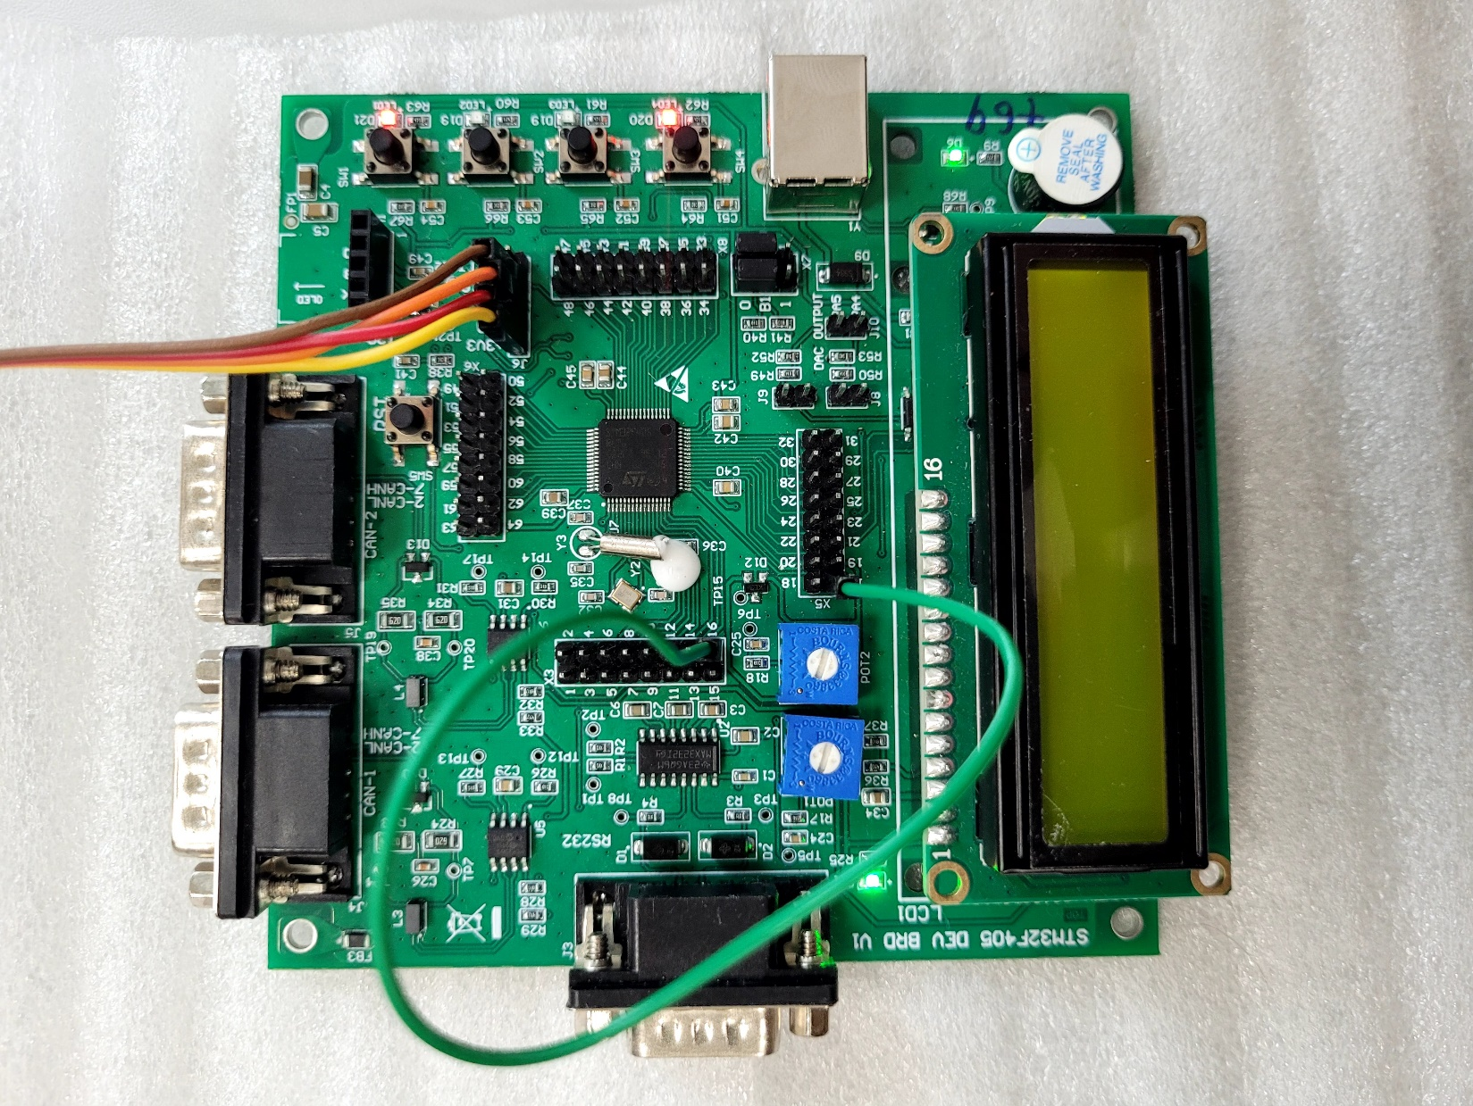

**WITH LCD:**

